Statements of Commitment to the Global Alliance Against Hunger and Poverty

Nature and purpose of this document (this section is for information only)
These Statements of Commitment are a core component of the Global Alliance against Hunger and Poverty. As stated in its Terms of Reference and Governance Framework, the Global Alliance's mission is to support and accelerate efforts to eradicate hunger and poverty (SDGs 1 and 2) while reducing inequalities (SDG 10), contributing to the achievement of other SDGs and championing just transition pathways. To do so, its high-level objectives are:
a) Provide sustained political drive at the highest level by the Group of 20 and other countries and organizations, galvanizing collective action and building upon synergies with other existing efforts to eliminate poverty and hunger across the world;
b) Facilitate mobilization and improved alignment of domestic and international support, including public and private financial resources and knowledge, to enable large-scale country owned and country-led implementation of proven policy instruments and programmes, especially by countries most affected by hunger and extreme poverty and focusing on persons in vulnerable situations and those most likely to be left behind.
The present Statements of Commitment are a key vehicle for advancing both of those objectives. They are how any entity, including national governments, national, regional and international organizations, funds, regional and multilateral development banks, civil society organizations, philanthropic institutions and others, can voluntarily become members of the Global Alliance.
The Statements of Commitment are designed to clearly define the commitments any of these entities make when they join the Alliance. They are not legally binding, and their full realization ultimately depends on the application of each partner's own laws, policies and procedures. At the same time, the Statements of Commitment are meant to express a robust declaration of intent by the Alliance’s members, acting as a catalyst of positive change.
The Statements of Commitment are therefore a critical point of departure to enable the Global Alliance to fulfill its dual role as an overall political driver of action to fight hunger and poverty, and as a matchmaker among its several constituencies, helping to muster the best array of knowledge and finance institutions in support of concrete policy implementation commitments by any of its partner governments. This is illustrated in the figure below, along with non-exhaustive examples of the types of support that can be offered in each of the three “Pillars”, which reflect the specific nature of the commitments made by each Alliance members.
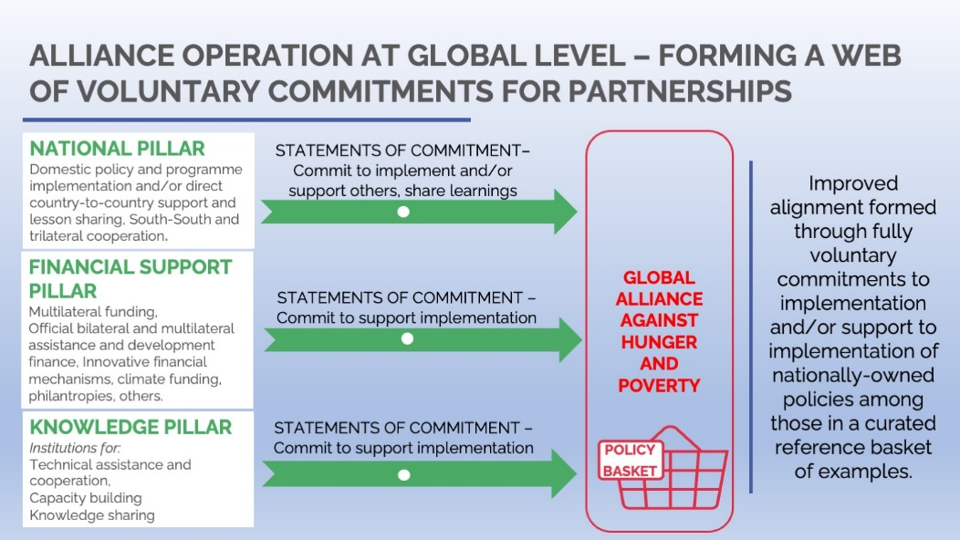
The wording of these proposed Statements of Commitment is meant to give the Global Alliance the necessary flexibility to work in partnership, leveraging and supporting the on-going work of a wide variety of initiatives, organizations, platforms and mechanisms in their efforts to fight poverty and hunger through country-driven, effective, and policy-oriented approaches.
Countries and other entities may decide who are the Ministries/Agencies/Departments issuing these Statements on their behalf. A Head of State level announcement on stage is expected with the presence of founding governments and organizations for the launch of the Global Alliance at the G20 Summit in November 2024.
Aside from a general section, to be endorsed by all entities wishing to join the Alliance, these Statements of Commitment include specific sections tailored for those wishing to join the Alliance’s National, Finance and Knowledge Pillars. Only country governments can join the National pillar (choosing to subscribe to one or to both subsections regarding policy implementation and policy support to others, respectively), and they can also, including through their government-led national finance and knowledge institutions, make additional commitments under the knowledge and finance sections. Non-government actors, including international organizations, international financial institutions, think tanks and philanthropic institutions can subscribe to the finance and knowledge sections as appropriate. All three pillars allow for optional, more specific commitments, highlighted in boxes in this document. Although those optional specific commitments are not mandatory and can be announced by members at a later stage, joining entities are encouraged to register them when joining the Alliance.
Finally, it helps to clarify that the current document is presented as a template. Actual Statements of Commitment for each individual country or organization joining the Alliance will be built based on the template but will only contain the sections applicable to the particular entity and omit any reference to optional commitments which were not made. Only the open-ended sections can be freely written, as the remainder of the template’s sections shall be subscribed on an equal basis by all members subscribing to those sections.

[Entity Name]

Statements of Commitment to the Global Alliance Against Hunger and Poverty

General section [Mandatory Section]
- [Entity Name] hereby voluntarily joins the Global Alliance Against Hunger and Poverty and states its dedication to pursue the Alliance's mission, objectives and principles, as expressed in the Global Alliance's Terms of Reference and Governance Framework, and to collaborate with other members to achieve lasting solutions to poverty and hunger worldwide, as expressed below.
[Entity Name]:
- Recognizes that hunger and malnutrition are the perverse manifestations of persistent, structural poverty and inequality, and recognizes the need to end poverty and hunger in all their forms and dimensions and to fully and effectively implement the 2030 Agenda.
- Acknowledges the alarming growth in the number of people facing food insecurity and poverty in recent years, noting that, despite all significant past and current efforts, the world is not on track to meet SDG 1 and 2 targets, inequality is also on the rise (SDG 10), and a significant increase in collective ambition, as well as improvement in collective alignment and coordination for the fight against hunger and poverty, is urgently needed.
- To that effect, endorses the Global Alliance Against Hunger and Poverty and its mission to support and accelerate efforts to eradicate hunger and poverty (SDGs 1 and 2) while reducing inequalities (SDG 10), contributing to revitalize global partnerships for sustainable development (SDG 17) and to the achievement of other interlinked SDGs, and championing sustainable, inclusive and just transitions.
- Notes that it is crucial for the world to unite behind large-scale, integrated approaches combining international, regional, national, and local levels, that recognize the interconnected nature of challenges and solutions to hunger and poverty and pair social protection with access to goods and services that can help the poor and vulnerable populations to overcome structural barriers and drive responsible investment in their productive capacity. These complementary services include but are not limited to interventions for poverty reduction, food security and nutrition, early childhood support, education and skills development, employment services, health and care services, as well as family farmers and smallholders’ access to finance, extension services, research and/or agricultural inputs, in line with international commitments and obligations.
- Particularly recognizes the high value and positive impact of quality implementation of national and local country-owned, inclusive policy instruments and programmes, focused on the poorest and most vulnerable, in the fields of poverty reduction, social protection, food security and nutrition, gender equality, decent work in the agri-food sector, skills development, family farming and smallholder agriculture, food systems transformation, health and care services and resilience building.
- Also acknowledges the Global Alliance’s reference basket of such policies as a collectively built, ongoing collection of examples with robust evidence to reduce hunger and poverty, and as a useful basis to guide joint action and increase alignment of the international community at country level. This acknowledgement is applicable to the policy basket approach as a general guide to action and does not imply endorsement of any specific policy instrument or programme contained in the basket.
- Therefore, by joining the Global Alliance Against Hunger and Poverty, commits to do its best efforts, in its own field of action, and according to its own mandate, capacities, priorities, preferences, procedures, and legal arrangements and framework, to support the implementation of policy instruments and programmes at country level as appropriate, including by the promotion of shared learning and the mobilization of resources, public and private, at scale.

In particular:

[NATIONAL PILLAR – include only if applicable]

Domestic policy implementation commitments [include only if applicable]
[Entity Name] acknowledges its role in the [national-level | regional-level] implementation of policies and programmes against hunger and poverty, as well as for providing guidance and support to [national and] sub-national level policies and programmes.
[Entity Name]:
Commits to make its best efforts to implement, improve, and/or scale-up the implementation of policy instruments and programmes from among those contained in the Global Alliance’s policy basket in our national context. These policy instruments and programme suggestions would be adapted to the specific conditions, realities and opportunities presented in our country.
[OPTIONAL SECTION]
In particular, [Entity Name] commits to implement, improve, or scale-up the implementation of the following policy instruments or programmes, referenced in the Global Alliance’s reference basket:
[LIST OF PROGRAMMES AND POLICIES THAT COULD FIT INTO ANY OF THE POLICY OR PROGRAMME TYPES INCLUDED IN THE ALLIANCE´S POLICY BASKET (FOR REFERENCE, CONSULT: https://globalalliance.socialprotection.org/). THE LIST CAN INCLUDE SHORT DESCRIPTIONS ABOUT SPECIFIC ASPECTS CONSIDERED RELEVANT BY THE GOVERNMENT]
1) Programme one: short description.
2) Programme two: short description
3) Programme three: short description
… others
[…]
Commits to observe good practices throughout the implementation of such policy instruments and programmes, including maintaining effective governance, seeking avenues for domestic resource mobilization for funding such programs and providing for appropriate monitoring and evaluation, with adaptation and learning based on social involvement and consultation, local stakeholder engagement, minimizing negative impacts and seeking to adequately manage policy trade-offs.

Policy cooperation and support commitments [KNOWLEDGE PILLAR – include only if applicable]
Commits to, within its capacities, share its own learnings and otherwise provide appropriate help and support, within its means, to other Global Alliance member countries to implement, improve, or scale-up the implementation of policies and programmes referenced in the Alliance’s basket.
[OPTIONAL SECTION]
Specifically, informs and commits to implementing the following actions, programmes, and other activities related to lessons-learned and international cooperation in support of the Global Alliance´s objectives:
[SHORT, DESCRIPTIVE, OPEN-ENDED LIST OF ACTIONS/COMMITMENTS RELATED IN PARTICULAR TO INTERNATIONAL COOPERATION AND LESSONS-SHARING IN POLICY IMPLEMENTATION. FIGURES, DATES, TARGET AREAS, AND OTHERS CAN BE LISTED AS DESIRED BY THE ENTITY] [500 words max].

[FINANCIAL PILLAR – include only if applicable]

Financial support commitments
[Entity Name]:
[OPTIONAL SECTION – EITHER OF THE OPTIONAL COMMITMENTS CAN BE TAKEN, IN ANY COMBINATION]
[1] Informs that an estimated amount of USD XXXXXX of financial resources under its guidance, management or control is currently being employed and/or may be allocated in the reference timeframe of [insert starting and end year] to provide international development support applicable to the fight against hunger and poverty and advancing SDGs 1 and 2. The amount informed is the best possible estimation considering different applicable modalities, allocations and budget cycles, and is subject to changing circumstances and budgets. It is not to be considered a pledge of new and additional resources.
[2] Announces a new and additional sum of USD XXXXXX, to be fully disbursed by [YEAR], to assist member states of the Global Alliance to implement, improve, or scale-up the implementation of policies within the Alliance’s policy basket.
[3] In addition to the above, informs and commits to implementing the following actions, programmes, and other activities in support of SDGs 1 and 2 and the Global Alliance´s objectives:
[SHORT, DESCRIPTIVE, OPEN-ENDED NARRATIVE OF RELEVANT ACTIONS/COMMITMENTS/GRANTS/AID PROGRAMMES PARTICULAR TO THAT ENTITY. FIGURES, DATES, TARGET AREAS, AND OTHERS CAN BE LISTED AS DESIRED BY THE ENTITY – 500 WORDS MAX]
Commits to make its best efforts to improve the destination, allocation and alignment of the use of its resources, including through coordination and cooperation facilitated by the Global Alliance, to support member countries to implement, improve, or scale-up the implementation of select programmes or policy instruments in the Alliance’s reference basket to drive the fight against hunger and poverty, in line with sustainable country-led financing and implementation strategies.

[KNOWLEDGE PILLAR – If not applicable use this field to state so, blocked text cannot be altered without rendering the whole pillar void]

Knowledge support commitments
[Entity Name]:
Commits to make its best efforts to co-create and provide technical assistance, capacity building and strengthening, training and/or knowledge-sharing on voluntary and mutually agreed terms in response to requests by Global Alliance member countries that choose to implement policy instruments and programmes in the Alliance's policy basket that are compatible with its areas of expertise.
Commits to make its best efforts to improve the alignment of its actions, including through the Global Alliance’s coordination mechanisms, leveraging, and partnering with other actors to better support large scale, country-owned implementation of policies and programmes in the reference basket by Global Alliance member countries, aiming at enhancing country-level outcomes.
Commits to collaborate with other Alliance members to develop innovative solutions and share good practices in learning and knowledge exchange and dissemination on voluntary and mutually agreed terms, data collection and analysis, including by leveraging existing local, national, and international knowledge networks, coalitions, communities and other fora related to aspects relevant to the fight against hunger and poverty.
[OPTIONAL SECTION - – EITHER OF THE OPTIONAL COMMITMENTS CAN BE TAKEN, IN ANY COMBINATION]
[1] Informs its capacity and readiness to support Alliance member governments in implementing, improving or scaling-up the following policy instrument types, referenced in the Global Alliance’s basket of policy instruments:

[LIST OF PROGRAMMES AND POLICIES CHOSEN FROM THE OPTIONS IN THE POLICY BASKET (FOR REFERENCE, CONSULT: https://globalalliance.socialprotection.org/). THE LIST CAN INCLUDE SHORT DESCRIPTIONS ABOUT SPECIFIC ASPECTS CONSIDERED RELEVANT BY THE INSTITUTION]
[2] Informs and commits to implementing the following actions, programmes, and other activities in support of the Global Alliance´s objectives:

[SHORT, DESCRIPTIVE, OPEN-ENDED LIST OF ACTIONS/COMMITMENTS PARTICULAR TO THAT ENTITY. FIGURES, DATES, TARGET AREAS, AND OTHERS CAN BE LISTED AS DESIRED BY THE ENTITY—500 words max]

General acknowledgments
Recognizes the possibility to, including through the mechanisms available to Global Alliance members, coordinate, partner with and/or seek support from the Global Alliance’s other members, within their respective capacities, availability, and fields of activity, to carry out the present commitments with greater effectiveness.
While recognizing that the above commitments are voluntary and non-legally binding, being subject to and carried out under its own capacities, regulations, priorities, and modalities, as well as to the availability of appropriate resourcing, strives to seriously consider, as appropriate, and according to its own legal frameworks and governance process, to review its procedures and priorities as found necessary to better deliver on the present commitments, enhance synergies and joint efforts with other entities and initiatives, and improve outcomes on the collective fight against hunger and poverty.

